Darnell Chen  
Lab 4 Report  
ECE 2031 L02  
19 February 2025

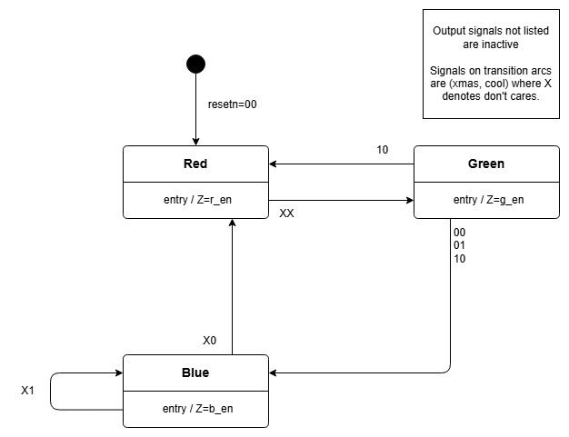

**Figure 1.** A state diagram that defines simplified input and output signals with a legend. The outputs are LED colors and the transition arcs define inputs as the pair ‘xmas, cool’.

**Table 1**Table for the State Machine *Q1+ = Q0⋅\xmas + Q0⋅cool + Q1⋅cool*   
and *Q0+ = \Q1⋅\Q0* with outputs determined by q1 and q0

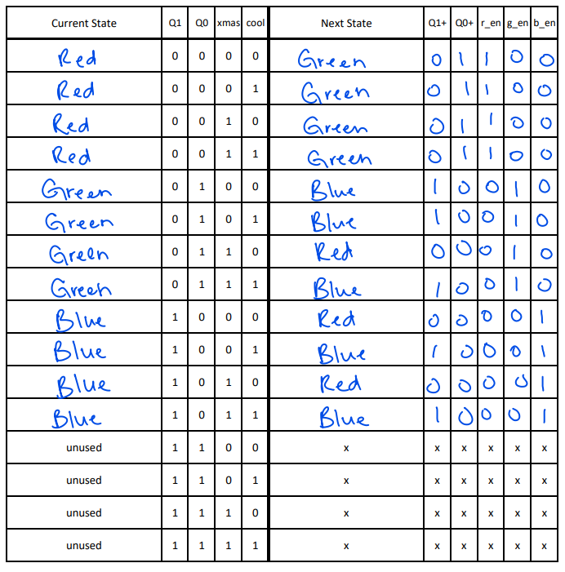

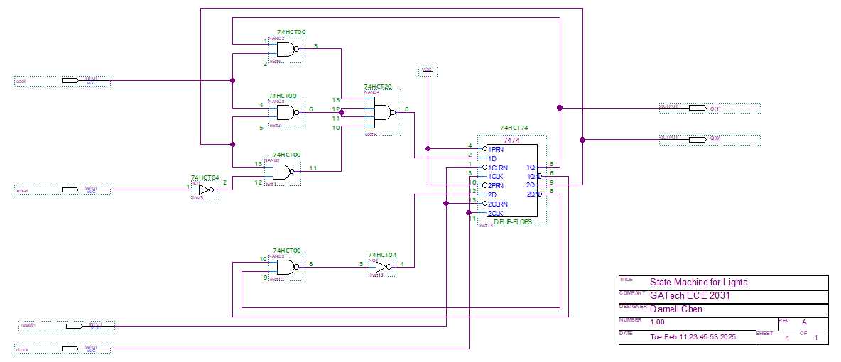

**Figure 2.** A 2-input circuit schematic that implements a Moore-output state machine using D Flip-Flops. The states for the circuit schematic follow the equations *Q1+ = Q0⋅\xmas + Q0⋅cool + Q1⋅cool* and *Q0+ = \Q1⋅\Q0.*

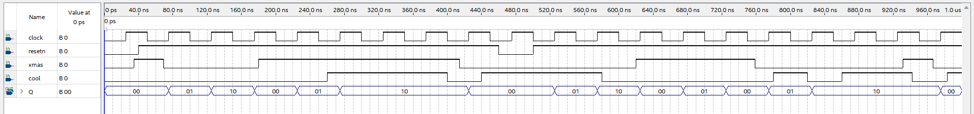

**Figure 3.** The waveform simulation for a circuit that implements a Moore output state machine. The inputs xmas and cool are the primary inputs that determine the next state for the vector Q. All input-output combinations were captured.

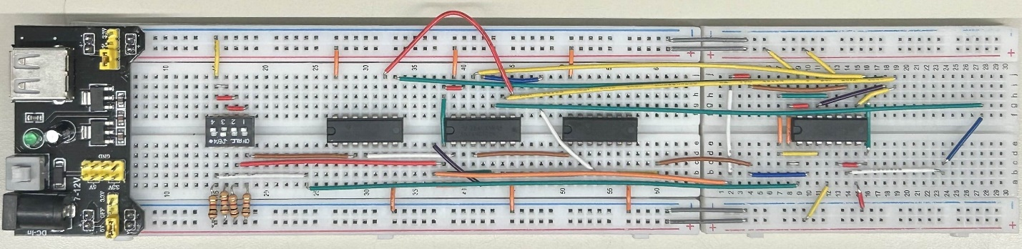

**Figure 4.** The hardware implementation of a state machine which follows the expressions   
*Q1+ = Q0⋅\xmas + Q0⋅cool + Q1⋅cool* and *Q0+ = \Q1⋅\Q0.*

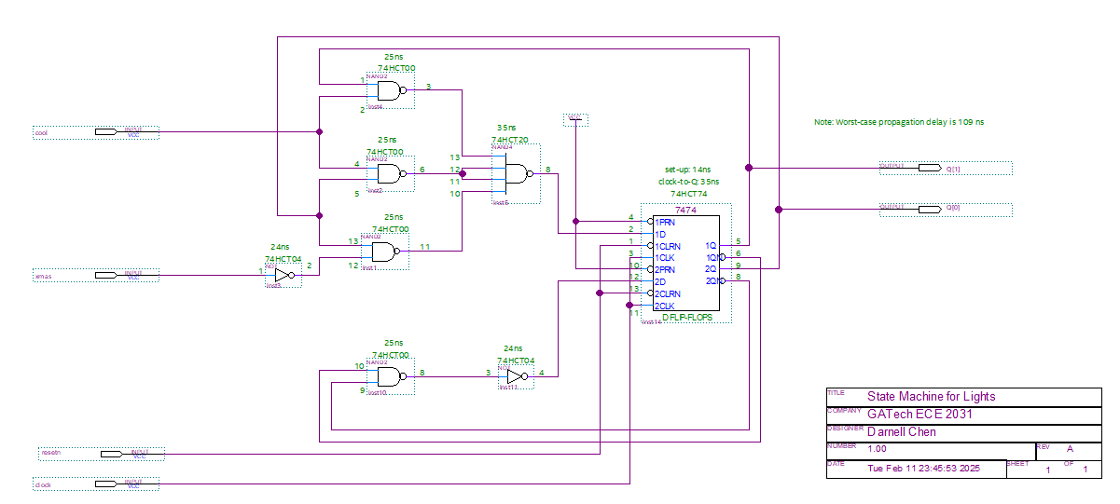

**Figure 5.** A circuit schematic for a Moore output state-machine with defined device labels, pin numbers, and delays for each device. The worst case propagation delay is noted to be 109 ns. The states for the circuit schematic follow the equations *Q1+ = Q0⋅\xmas + Q0⋅cool + Q1⋅cool* and *Q0+ = \Q1⋅\Q0.*